Blossom Watch 2021

Alan Millington

2021-03-19 16:12:16

|  |  |
| --- | --- |
| hashtag | count |
| blossom | 1995 |
| blossomwatch | 1108 |
| NationalTrust + BlossomWatch | 28 |
| EveryoneNeedsNature | 147 |
| None | 1376 |

# Timeline

## Tweets by day

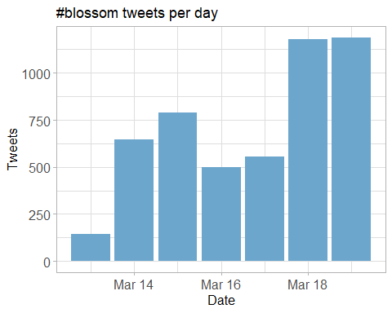

## Tweets by day and time

Filtered for dates March, London time. 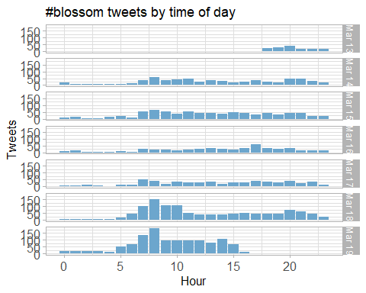

# Users

## Top tweeters

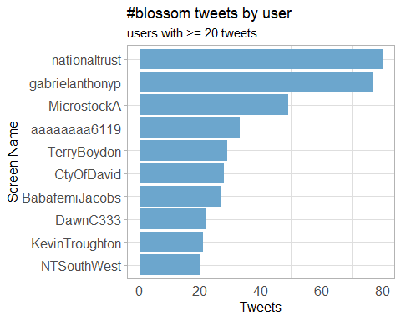

## Sources

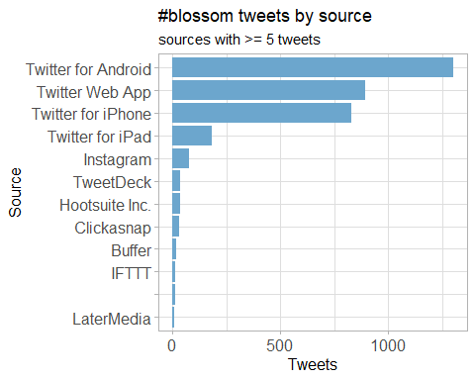

# Networks

## Replies

The “replies network”, composed from users who reply directly to one another.

Better to view the original PNG file in the data directory.



## Mentions

The “mentions network”, where users mention other users in their tweets.

Better to view the original PNG file in the data directory.

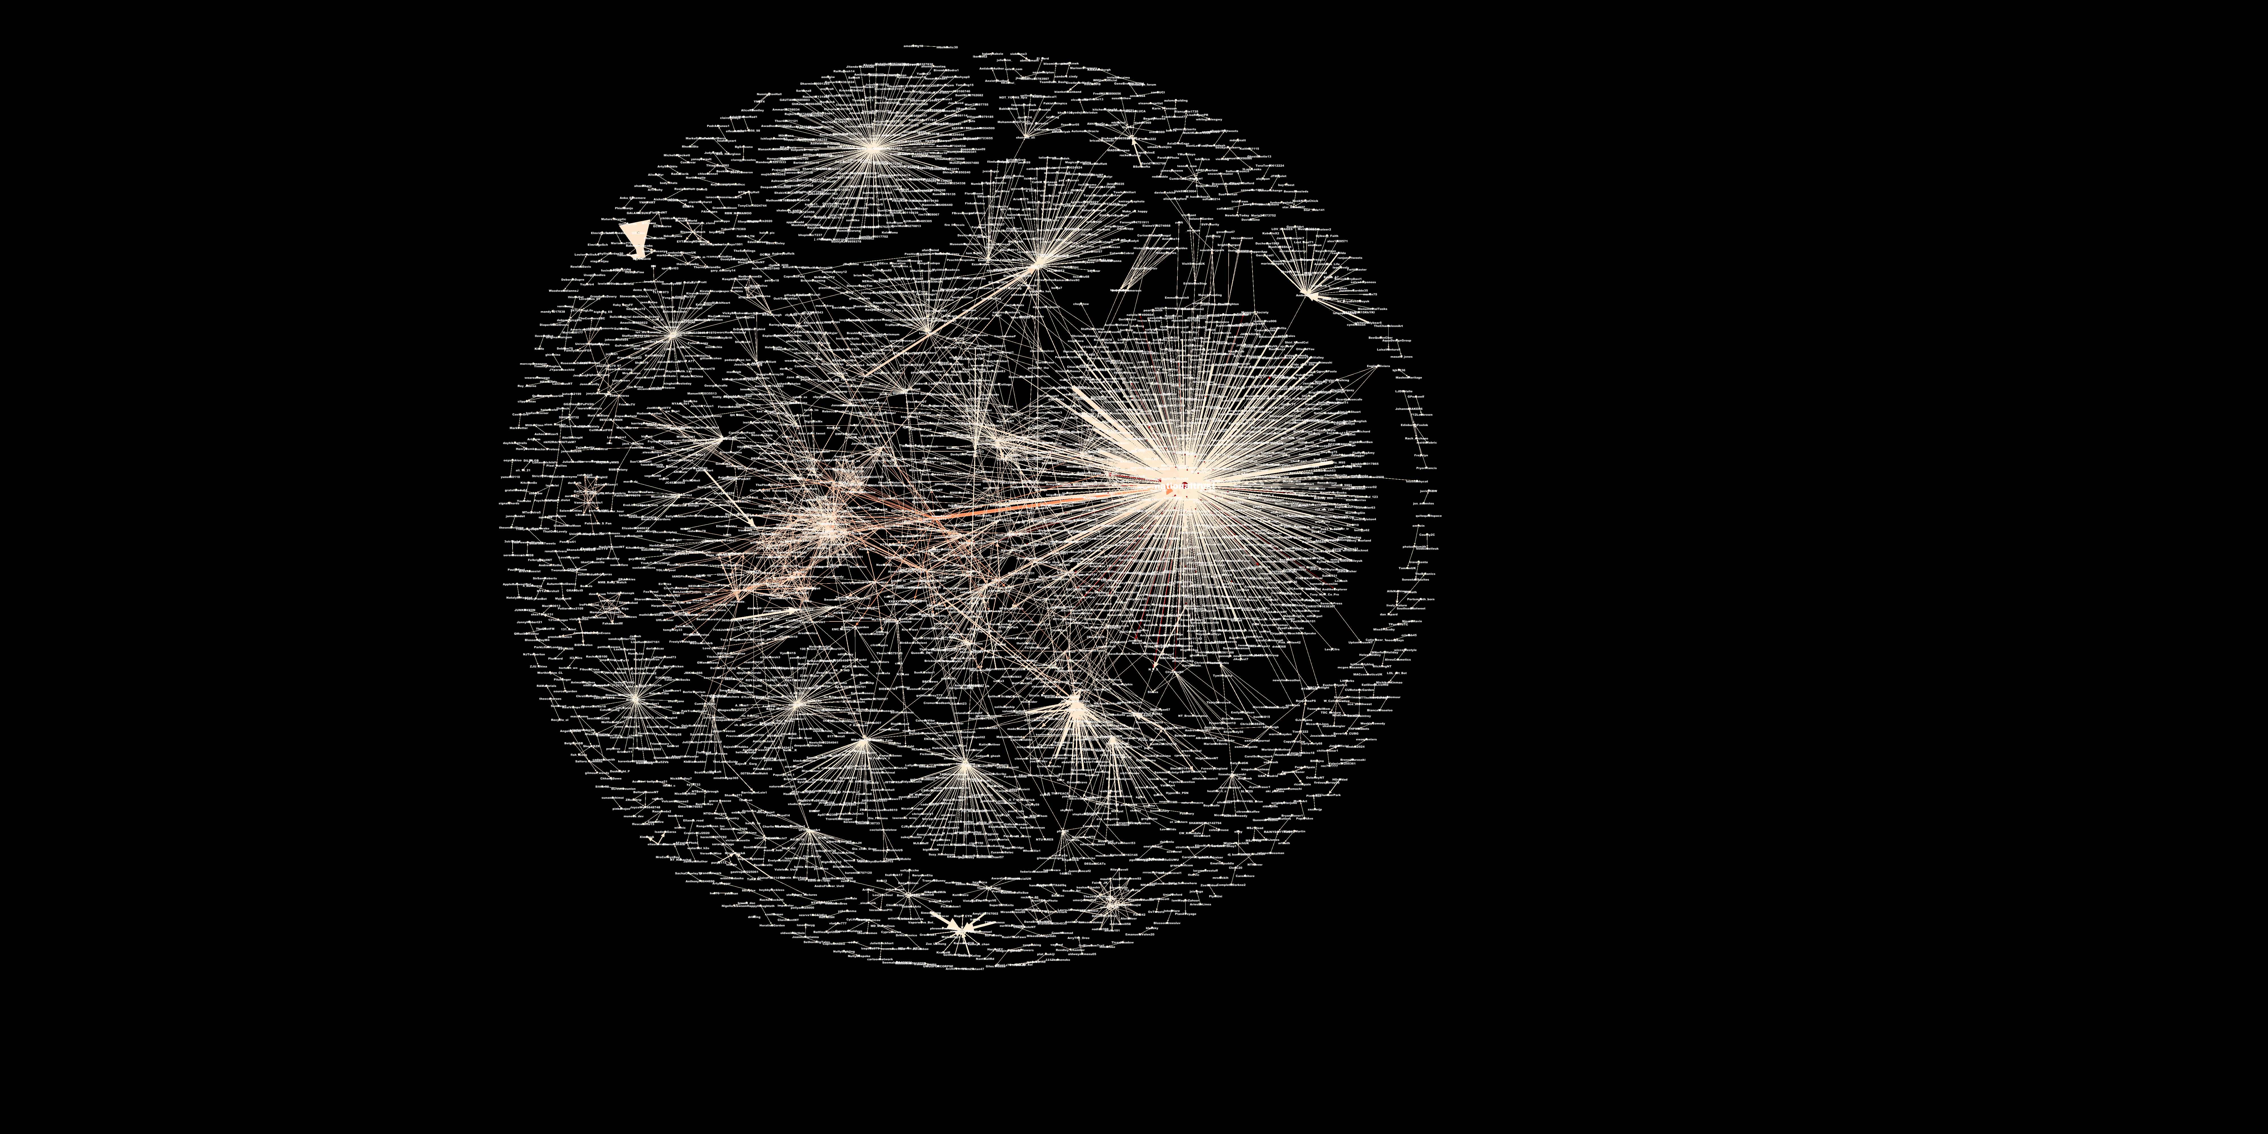

# Retweets

## Retweet proportion

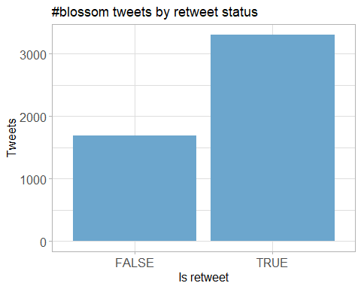

## Retweet count

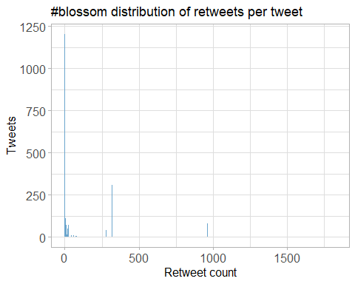

## Top retweets

|  |  |  |
| --- | --- | --- |
| screen_name | text | retweet_count |
| KhushnumaKashm1 | Apricot #blossom #Kashmir #spring <https://t.co/YBDM7JMLbY> | 320 |
| nationaltrust | Spring is on the way. Celebrate the arrival of blossom near you with #BlossomWatch: <https://t.co/TaQxr1YkU8> <https://t.co/kQ93UDZlCP> | 109 |
| nationaltrust | If you’re lucky enough to spot a hare hopping around, the feeling of elation will stick with you all day. #EveryoneNeedsNature <https://t.co/Vpo5aADU9Q> | 99 |
| dadajay001 | <U+0917><U+0941><U+0932><U+093E><U+092C> <U+0938><U+0940> <U+091C><U+093F><U+0902><U+0926><U+0917><U+0940> <U+0939><U+0948> <U+0928><U+093E> <U+0915><U+093E><U+0902><U+091F><U+094B><U+0902> <U+0915><U+093E> <U+0926><U+0930><U+094D><U+0926> <U+0939><U+0948> <U+0928><U+093E> <U+092A><U+0902><U+0916><U+0941><U+0921><U+093C><U+093F><U+092F><U+094B><U+0902> <U+0915><U+0940> <U+0916><U+0941><U+0936><U+092C><U+0941>…. <U+2728><U+2764><U+FE0F> #Petals #Blossom #My_click <https://t.co/kEbXfNpjI7> | 96 |
| nationaltrust | Everywhere these delicate flowers emerge, they bring delight with them. Thanks to everyone who’s helped spread the joys of blossom so far - keep the photos coming with #BlossomWatch. Photos: Joanna A, Catherine A, Shonali B, Cara W. <https://t.co/6znNDEdvKC> | 87 |
| nationaltrust | <U+0001F338>#BlossomWatch<U+0001F338> Lockdowns have changed the nation’s relationship with nature for the better. We are feeling more connected thanks to our daily strolls and taking more notice of the changing seasons. <https://t.co/JtIkqgUorV> | 78 |
| AlanDaffern | <U+0001F525>Make #TooHotToHandle<U+0001F525> 18 month old #Blossom was taken during a callous burglary on the 4th March 2021 in #Pudsey #Leeds #Yorkshire #LS28. Her family returned in the afternoon to find their home had been been ransacked and Blossom and her toys #Missing <https://t.co/ncm9Eesdo6> <https://t.co/IHsFqk2dXg> | 73 |
| ampomata | This is my new painting “Bed Of Roses”. You can check it out here: <https://t.co/GoYnqeM1YY> #art #arte #oleo #kunst #oilpainting #contemporaryart #ArtistOnTwitter #blossom #flower #floral #spring #pink #red #roses #field #artprints #flowers #garden <https://t.co/7y9skbUaMs> | 67 |
| MikeDoylePhotos | Spring colour at Sheffield Park, East Sussex. #Sussex #England #NationalTrust #landscape #landscapephotography #travel #travelphotography #photo #photography #photooftheday #NaturePhotography <https://t.co/uFdcfnor39> | 51 |
| nationaltrust | <U+0001F338> With buds beginning to burst weâ€™re asking you to help us track the blossom as it appears. Just add #BlossomWatch to your tweets, with location settings on, to add your sightings to our map: <https://t.co/Oto3d8C9ZQ> <https://t.co/9a3Q2umF03> | 49 |

# Favourites

## Favourite proportion

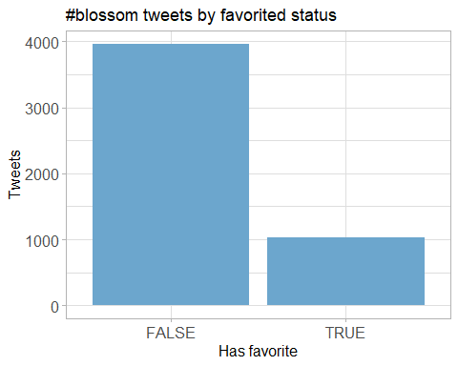

## Favourite count

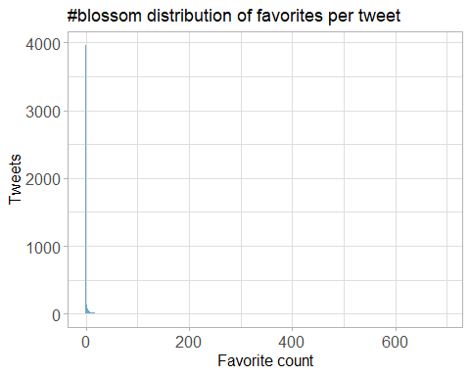

## Top favourites

|  |  |  |
| --- | --- | --- |
| screen_name | text | favorite_count |
| nationaltrust | If you’re lucky enough to spot a hare hopping around, the feeling of elation will stick with you all day. #EveryoneNeedsNature <https://t.co/Vpo5aADU9Q> | 695 |
| nationaltrust | <U+0001F338>#BlossomWatch<U+0001F338> Lockdowns have changed the nation’s relationship with nature for the better. We are feeling more connected thanks to our daily strolls and taking more notice of the changing seasons. <https://t.co/JtIkqgUorV> | 512 |
| nationaltrust | Everywhere these delicate flowers emerge, they bring delight with them. Thanks to everyone who’s helped spread the joys of blossom so far - keep the photos coming with #BlossomWatch. Photos: Joanna A, Catherine A, Shonali B, Cara W. <https://t.co/6znNDEdvKC> | 510 |
| nationaltrust | Spring is on the way. Celebrate the arrival of blossom near you with #BlossomWatch: <https://t.co/TaQxr1YkU8> <https://t.co/kQ93UDZlCP> | 467 |
| nationaltrust | Nature’s alarm clock is getting louder with each new day as the birds look to find their spring mates. Which birds are waking you up in the morning? Photos: Jenni B, @NTCastleWard #EveryoneNeedsNature <https://t.co/qFLlRf3gL7> | 412 |
| MikeDoylePhotos | Spring colour at Sheffield Park, East Sussex. #Sussex #England #NationalTrust #landscape #landscapephotography #travel #travelphotography #photo #photography #photooftheday #NaturePhotography <https://t.co/uFdcfnor39> | 368 |
| nationaltrust | As the days lengthen, take an early evening walk and listen out for the blackbird chorus. Perched as high as they can, they fill the spring air with song. #EveryoneNeedsNature <https://t.co/fokl4eudbL> | 366 |
| KhushnumaKashm1 | Apricot #blossom #Kashmir #spring <https://t.co/YBDM7JMLbY> | 347 |
| nationaltrust | A bright burst of yellow Forsythia is like the sunshine after the rain. Flowering with the spring bulbs, these blooms are a sure sign of the gardens we care for reawakening after winter. #EveryoneNeedsNature <https://t.co/eRc7pCw2nJ> | 318 |
| nationaltrust | When you stand under an outstretched branch with its flowers bursting into life, take a moment to focus on the tiny details and get lost in nature. Photo: Trudi H, @TyntesfieldNT #EveryoneNeedsNature #BlossomWatch <https://t.co/7pgrQTE4SI> | 283 |

# Quotes

## Quote proportion

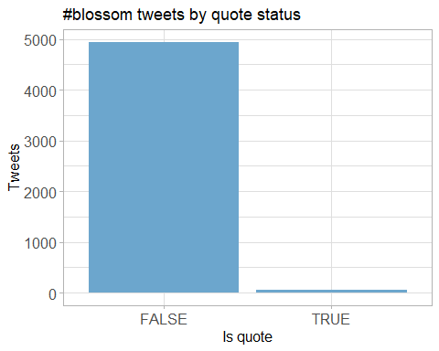

## Quote count

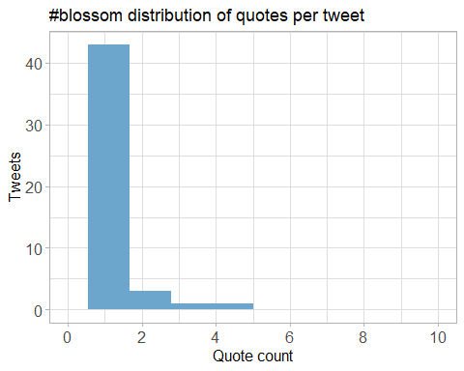

## Top quotes

Joining, by = “quoted_status_id”

|  |  |  |
| --- | --- | --- |
| screen_name | text | quote_count |
| WadesWords13 | #BlossomWatch #BuryStEdmunds #Suffolk <U+0001F600> <https://t.co/3K9z3736Qa> <https://t.co/1vHuj2wDlX> | 4 |
| wearealtervego | Taking in the #nature around us…#andbreathe #blossomwatch #savethebees #savetheworld <https://t.co/9OKBi1ot9E> | 4 |
| GillianFoxcroft | Wonderful initiative by @nationaltrust Lucky enough to live near @KedlestonNT where this blackthorn was heralding spring, but blossom is accessible in our towns and cities too #BlossomWatch <https://t.co/l3nMn9dvGe> <https://t.co/Nri4nxd3vL> | 4 |
| MedialabGroup | For what is probably the most anticipated spring in decades, we are incredibly proud to have supported our partner @nationaltrust in launching their latest Blossom campaign. The National Trust Blossom campaign runs across TV, national press and digital. #BlossomWatch <https://t.co/wMan1xCxRM> | 4 |
| DerbyUniPress | Research @DerbyUni is making important contributions to initiatives designed to enhance our #wellbeing and strengthen our relationship with #nature, such as @nationaltrust #BlossomWatch, which has been launched today. @findingnature <https://t.co/c4ZAhGJs1Q> | 3 |
| JonathanD1962 | @issybryonyh #BlossomWatch <https://t.co/9CLkjUkytC> | 3 |
| MiriamDobson | Great blog & paper! #BlossomWatch is such a fantastic opportunity to engage with moments in nature - these simple moments of noticing are so important for wellbeing (as this research demonstrates!) <https://t.co/pBwUoaQ3ZS> | 3 |
| weather2travel | Will you be joining @nationaltrust #BlossomWatch? <U+0001F338><U+0001F440> #thursdaymorning #ThoughtForTheDay #spring #bliss <https://t.co/aiQYIY1n5N> | 2 |
| HeiniHeikkil | Mesmerising, refreshing blossom shared by millions in social media <U+0001F338>#UKhanami #BlossomWatch <https://t.co/Ut9p5H0aEL> | 2 |
| NaturalEngland | Our research shows that nature is more important than ever to us since the pandemic started. We’re taking more notice of small changes in nature and signs of spring, like beautiful apple blossom. Share your pictures of blossom with @NationalTrust using <U+0001F338>#BlossomWatch <U+0001F338> <https://t.co/KlDTIYa46E> | 2 |

# Media

## Media count

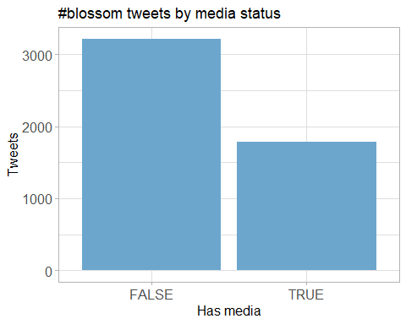

## Top media

|  |  |  |
| --- | --- | --- |
| screen_name | text | favorite_count |
| nationaltrust | If you’re lucky enough to spot a hare hopping around, the feeling of elation will stick with you all day. #EveryoneNeedsNature <https://t.co/Vpo5aADU9Q> | 695 |
| nationaltrust | <U+0001F338>#BlossomWatch<U+0001F338> Lockdowns have changed the nation’s relationship with nature for the better. We are feeling more connected thanks to our daily strolls and taking more notice of the changing seasons. <https://t.co/JtIkqgUorV> | 512 |
| nationaltrust | Everywhere these delicate flowers emerge, they bring delight with them. Thanks to everyone who’s helped spread the joys of blossom so far - keep the photos coming with #BlossomWatch. Photos: Joanna A, Catherine A, Shonali B, Cara W. <https://t.co/6znNDEdvKC> | 510 |
| nationaltrust | Spring is on the way. Celebrate the arrival of blossom near you with #BlossomWatch: <https://t.co/TaQxr1YkU8> <https://t.co/kQ93UDZlCP> | 467 |
| nationaltrust | Nature’s alarm clock is getting louder with each new day as the birds look to find their spring mates. Which birds are waking you up in the morning? Photos: Jenni B, @NTCastleWard #EveryoneNeedsNature <https://t.co/qFLlRf3gL7> | 412 |
| MikeDoylePhotos | Spring colour at Sheffield Park, East Sussex. #Sussex #England #NationalTrust #landscape #landscapephotography #travel #travelphotography #photo #photography #photooftheday #NaturePhotography <https://t.co/uFdcfnor39> | 368 |
| nationaltrust | As the days lengthen, take an early evening walk and listen out for the blackbird chorus. Perched as high as they can, they fill the spring air with song. #EveryoneNeedsNature <https://t.co/fokl4eudbL> | 366 |
| KhushnumaKashm1 | Apricot #blossom #Kashmir #spring <https://t.co/YBDM7JMLbY> | 347 |
| nationaltrust | A bright burst of yellow Forsythia is like the sunshine after the rain. Flowering with the spring bulbs, these blooms are a sure sign of the gardens we care for reawakening after winter. #EveryoneNeedsNature <https://t.co/eRc7pCw2nJ> | 318 |
| nationaltrust | When you stand under an outstretched branch with its flowers bursting into life, take a moment to focus on the tiny details and get lost in nature. Photo: Trudi H, @TyntesfieldNT #EveryoneNeedsNature #BlossomWatch <https://t.co/7pgrQTE4SI> | 283 |

### Most liked media image

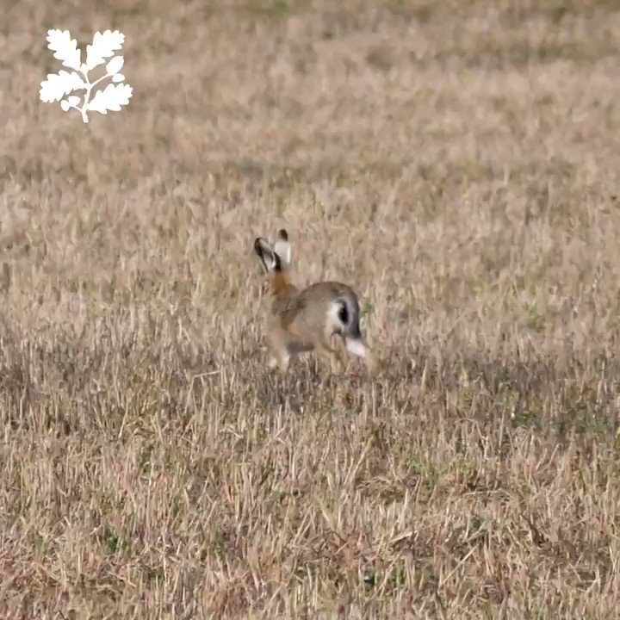

# Tweet text

The 100 words used 3 or more times.

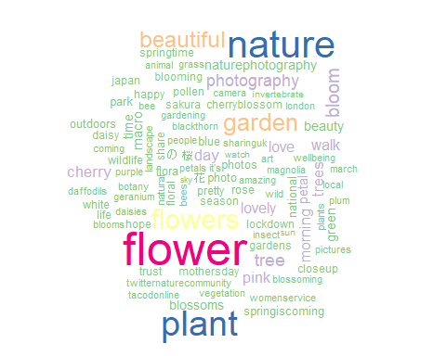

## Who has 280 characters?

